Phase 3

9 classes

Day 5 : June 11 2024

Spring MVC with JPA

Create dynamic web project and then we need to convert this project to maven.

Dependencies 🡪

1. Spring mvc @Controller, @Service, @Repository and @Autowired
2. Mysql connector it provide type 4 mysql class to connect to database.
3. Jpa dependencies it provide jpa API like EntityManagerFactory, EntityManager, EntityTransaction
4. Spring jdbc : it provide datasource
5. Spring orm : it help to integrate with jpa and spring framework

*LocalContainerEntityManagerFactoryBean: it is a pre defined class provided by spring orm module which help to integrate with JPA.*

Limitation of spring framework

1. We need to do more configuration using xml or annotation.
2. Maintaining jar file or dependencies.

Spring boot : Spring boot is use to do the bootstrap for existing or new spring modules.

CSS -🡪 Spring framework

Bootstrap 🡪 spring boot

Spring boot = all spring modules – no xml file + few annotation + embedded internal web server.

Spring boot components

1. Spring boot starter : Spring boot provided lot of pre defined starter which help to add all required jar with only one dependencies tag base upon type of application we develop.

Web starter

Jdbc starter

Jpa stater

Testing starter

Aop starter

Etc

1. Spring boot auto configuration : base upon type of starter we added inside spring boot project. Spring boot ready to inject those resources.

To reduce xml file configuration for resources.

@SpringBootApplication : this is new annotation we need to use in spring boot which is equal to

@Configuration + @ComponentScan + @AutoConfiguration

In spring boot we need to write all configuration details in

1. application.properties
2. application.yml

spring boot itself is core java project means it contains main class with main method which help to create any type of application. This main class only useful in development mode not in production mode.

Spring boot with

Maven : pom.xml . pom.xml file is part of maven tool. It is not a part of spring boot.

Gradle : in Gradle is xml less build tool. Build file to add all starter.

<https://start.spring.io/> this is official website which help to create spring boot project template.

Creating simple spring boot application with starter as

1. web starter

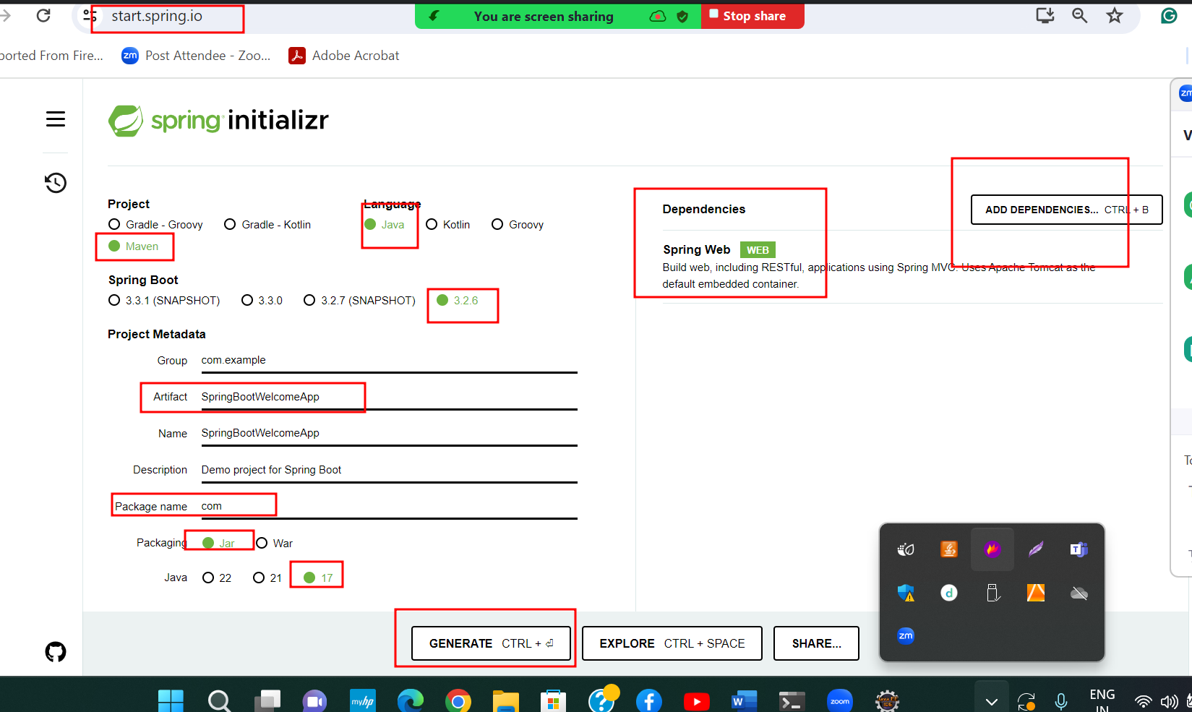

Spring boot internal or embedded tomcat start on port number 8080

Application.properites

server.port=9090